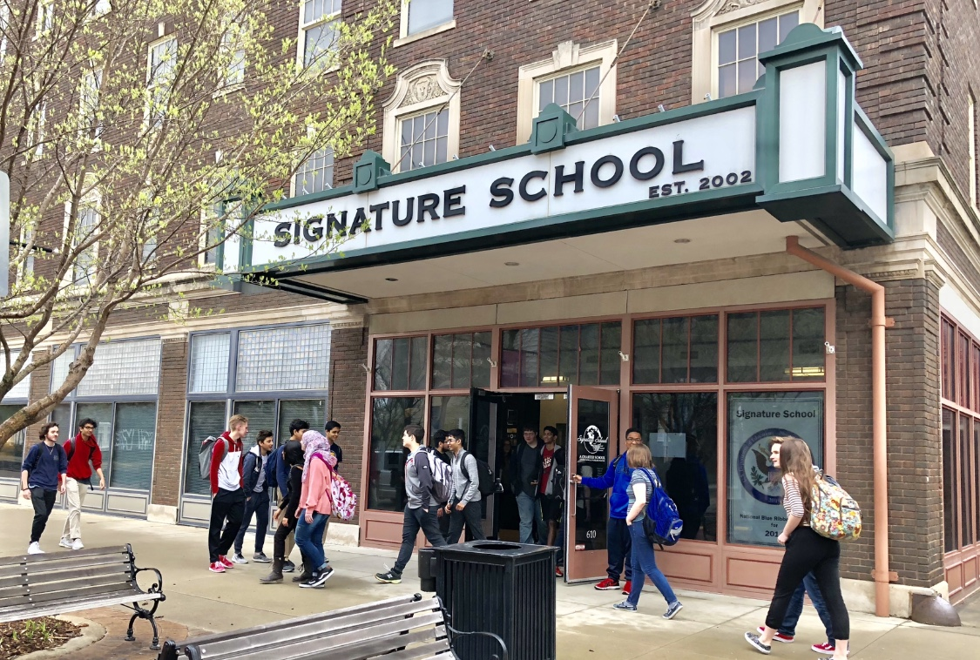

Artificial Intelligence at Signature School

DRAFT: May 2024



What is AI?
Artificial intelligence or “AI” has existed in the algorithms of machines since the early days of digital computing. AI had a very simple start but rose to prominence in the 90’s, winning chess matches against the world’s best players. It would go on to touch every aspect of the digital world, ranging from simple tasks such as navigating a map all the way to today where it can generate content, images, and even computer code.
Today the AI landscape looks much different because of the advances in technology that have led to the introduction of Generative AI, a widely available computer program that has access to a vast array of human knowledge and can in turn output content related to that knowledge. This creates challenges in the world of education where the goal is the acquisition of knowledge with the intention of developing new and original work that advances society.
AI can present an obvious issue for educators who want their students to absorb knowledge and think critically about what they have learned and achieve mastery over their work. This is verified through the submission of authentic and original work. The use of AI can either enhance that learning or impede it. The strategies and guidelines discussed in this document are intended to provide faculty, staff, and students with the information needed to understand the appropriate and safe use AI at Signature School.
With the fast-paced and ever-evolving nature of AI, please always refer to the most recent and up to date version of this document.
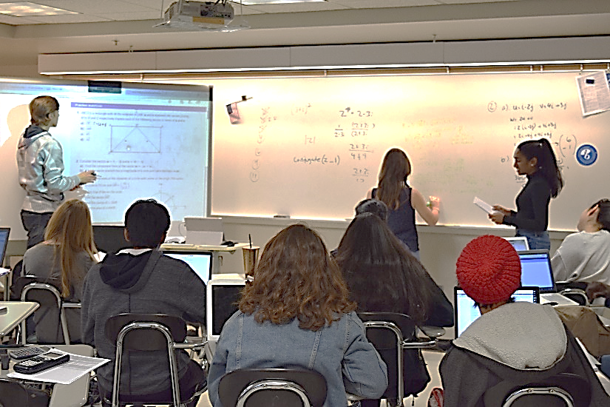



Strategies for the safe use of AI
  - 1. Data Privacy and Security: Ensure that any data collected or processed by AI tools in the classroom is handled securely and in compliance with relevant privacy regulations. This includes obtaining appropriate consent from students or guardians and implementing robust security measures to protect sensitive information.

  - 2. Transparency and Explainability: Select AI tools that provide transparency into their algorithms and decision-making processes. Students and teachers should understand how AI systems work and be able to interpret their outputs. This transparency helps build trust and enables users to identify and address any biases or errors in the AI's process.

  - 3. Ethical Use of Data: Use AI to enhance learning experiences while respecting the ethical consequences of data usage. Avoid using AI to make high-stakes decisions or evaluations without human oversight and ensure that AI tools do not perpetuate bias or discrimination.

  - 4. Equal Access: Ensure that AI tools are accessible to all students, regardless of their backgrounds or abilities. Consider how AI may impact different student populations and strive to mitigate any potential disparities. Provide training and support to ensure that teachers and students alike can effectively use AI tools.

  - 5. Continuous Monitoring and Evaluation: Regularly monitor and evaluate the performance of AI tools in the classroom to ensure they are achieving their intended educational outcomes. Be prepared to adjust or discontinue the use of AI tools if they are not meeting expectations or if they pose risks to students' well-being.

  - 6. Empowering Teachers: Provide teachers with the training and resources they need to effectively integrate AI into their teaching practices. Encourage educators to critically evaluate AI tools and to use them in ways that align with their instructional goals and values.

  - By following these strategies and examples, teachers can leverage the power of AI to enhance learning experiences in the classroom while prioritizing the safety, privacy, and well-being of students.

Policies and Guidelines - Artificial Intelligence
  - Policy on the Appropriate Use of Artificial Intelligence (AI) at Signature School.

  - 1. Purpose:
  - The purpose of this policy is to establish guidelines and procedures for the responsible and ethical use of Artificial Intelligence (AI) technology within Signature School. This policy aims to ensure that AI tools and applications are utilized in a manner that promotes student learning, privacy, safety, and equity.

  - 2. Scope:
  - This policy applies to all students who utilize AI technology within the school premises or as part of school-related activities.

  - 3. Definitions:
  - - Artificial Intelligence (AI): AI refers to computer systems or programs that can perform tasks typically requiring human intelligence, such as learning, reasoning, problem-solving, and decision-making.
  - - AI Tools: AI tools include software applications, algorithms, platforms, and devices that incorporate AI technology to support various educational activities and functions.

  - 4. Guidelines for the Appropriate Use of AI:
  - a. Educational Purpose: AI technology should be used primarily to enhance teaching and learning experiences, support educational objectives, and promote student achievement and engagement.
  - b. Authenticity and Originality: Work submitted should be the original and authentic work of each student. Students are expected to follow the rubric and instructions provided on all assignments and the work they submit should be their own. Submitting work generated (either partially or completely) by AI tools violates this expectation and is subject to both academic and disciplinary consequences.
  - c. Privacy and Data Security: All AI tools and applications used within Signature School must comply with relevant privacy laws and regulations. Any data collected or processed by AI tools must be handled securely and used solely for educational purposes.
  - d. Equal Access: The use of AI technology should promote equal student access to AI tools within the school community. Efforts should be made to ensure that all students have access to AI tools and opportunities, regardless of their background or abilities.
  - e. Ethical Use: AI technology should be used in an ethical and responsible manner, with consideration for its potential impact on students, teachers, and the broader community. AI tools should not be used to discriminate, harass, or harm individuals or groups.
  - f. Signature School’s Acceptable Use Policy is incorporated into its Policies and Guidelines – Artificial Intelligence by this notice.

